ARTIFICIAL INTELLIGENCE IN HEALTHCARE
1st V. Sravan Reddy 2nd Rakesh Kalshetty
Department of CSE (Cyber Security) Department of CSE (AI and ML)
Ramaiah Institute of Technology Ramaiah Institute of Technology
Bangalore, Karnataka, India Bangalore, Karnataka, India
sravanreddyv.work@gmail.com rakeshk.work@gmail.com

Abstract—In this paper, the study highlights and discusses the various modern applications of Artificial Intelligence, Machine Learning etc., in the healthcare sector. Today AI is revolutionising, strengthening healthcare through various technologies which can predict, grasp and act. The study mainly focuses on areas of AI-powered healthcare particularly in the fields such as Cardiology, Dermatology, oncology, pharmacy, Covid-19, speech recognition, for administration etc. The technologies like AI, machine learning, deep learning, neural network models have assisted doctors in diagnosing patients quickly, thus producing highly accurate results. Deep learning is mainly used in recognition of cancerous lesions in radiology images. Natural language processing helps in creating and understanding clinical documentation of patients. Patients’ medical data is also analysed by Artificial intelligence, which helps the physician in assisting the patients to improve their quality of life. Surgical robots used by surgeons to make minimal incisions, stitch wounds. Robots are given AI based brains, so image recognition is done by RPA (robotic process automation). Physical robots are nowadays used for various activities in hospitals like delivering supplies etc. Few startups are developing AI derived image interpretation algorithms. AI in healthcare is responsible for lack of job impact.
Keywords——Artificial Intelligence, Machine Learning, Robotic Process Automation, Natural language processing, Convolution Neural Network (CNN), Computer Tomography
I. INTRODUCTION
Artificial intelligence in healthcare is used to describe the use of machine learning algorithms and software or Artificial intelligence to copy human cognition in the analysing, presenting, and understanding of complex medical and health care data. The main objective is to replicate the human capabilities by providing new ways in diagnosing, treating, or preventing diseases. AI uses the computer algorithms to arrive at approximate conclusions based on input data.
In practice AI programs are applied in different healthcare areas such a diagnosis, treatment protocol development, drug discovery, personalized medicine and patient monitoring and care. AI gathers and processes larger and more different data, and thus produces a well- defined output to improve patient satisfaction, and addressing their staffing and workforce needs. Now a days many Companies are developing technologies that help health care, managers improve business operations. These technologies not only decrease patient boarding, but also reduces length of stay and optimizing staffing levels. With the help of AI-driven solutions, health care organisations can deliver their operations with more efficiency even to remote areas to improve patient outcomes and reduce cost.
II. CLINICAL APPLICATIONS
Cardiology—Artificial intelligence algorithms have shown best results in accurately diagnosing and risk stratifying patients with concern for coronary artery disease. Other algorithms have been used in predicting patient mortality.AI does this by using machine learning algorithms and deep learning. As AI in health care is relatively new, research is ongoing into its application in various fields of medicine and industry.
Now days hospitals are looking to AI software to support operations that increase cost saving, medication effects, and adverse events following treatment for acute coronary syndrome.
Applications of AI in cardiac imaging analysis include intravascular ultrasound (for the detection of the border of the lumen and the media-adventitia), optical coherence tomography (for the classification of the three layers of the coronary artery), cardiac single-photon emission computed tomography (for the diagnosing accuracy of myocardial ischemia and for the improvement of the diagnostic accuracy of myocardial perfusion imaging) and MRI (for the efficient and fast visualization of the cardiac segmentation in short axis MRI). In future deep learning will make imaging diagnostics are more reliable, easier and faster to obtain results. 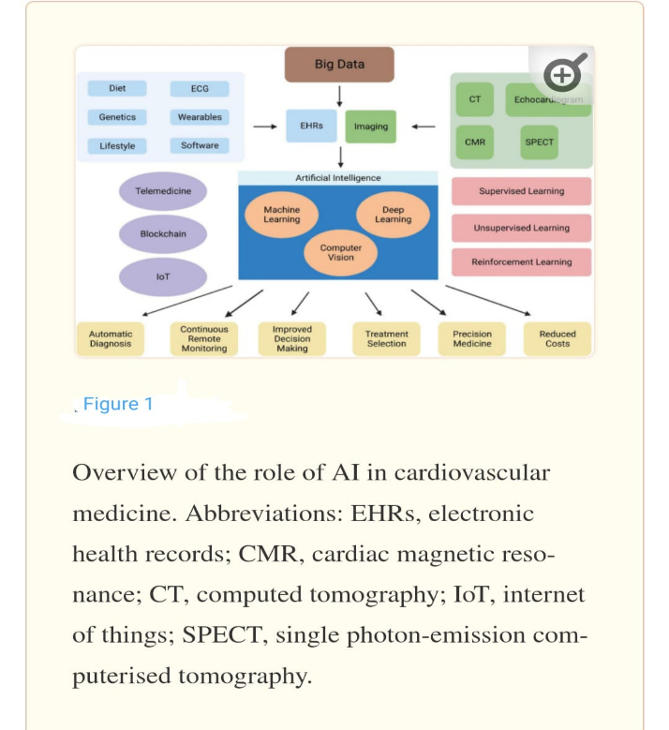
In future, the combination of AI and Surgical Robot can make use of automated surgery more realistic, which will reduce trauma to patient, improve surgical safety and shorten hospital stays. With this invention AI can perform percutaneous coronary intervention operations and catheter ablations of atrial fibrillation, on patients; which will reduce the radiation exposure for the doctors from the use of digital subtraction angiography.
Dermatology—Artificial intelligence is used in dermatology on a wide range, ranging from skin malignancies to inflammatory skin conditions, dermatopathology, to text- based analysis. Application of AI in dermatologic malignancies include identifying and distinguishing between benign nevi and melanoma. The first case represented the identification of the most common cancers; the second represented the identification of the deadliest skin cancer. Apart from melanomas and other malignant skin conditions AI is used in identification of psoriasis, dermatitis and acne. A majority of work is focused on psoriasis identification and classification through images of skin, nails, and scalp using CNN’s and other DL techniques. Convolution neural network (CNN) has been developed to detect psoriatic lesions by dermoscopic and clinical images. Dermoscopy increases the image resolution, removes surface reflections, and thus provides more detailed information about a lesion. Deep learning is used to develop an efficient skin cancer classification system with small dataset of clinical images. It also helped in classification of skin lesions using a single convolution neural network, trained end to end from images directly, using only pixels and disease labels as inputs.
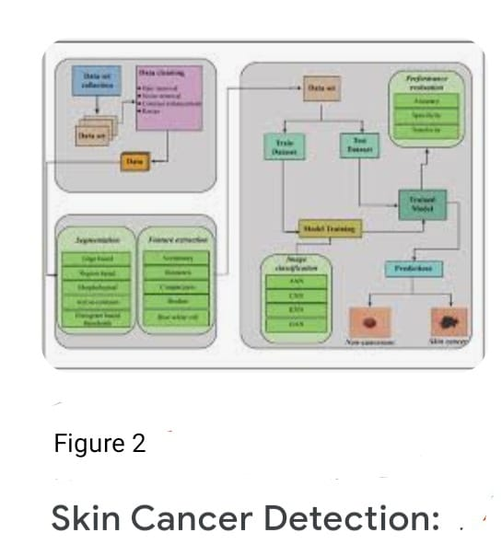
Pharmacy—AI systems are also used in health care sector to enhance patient experience, patient care and provide support to physicians through the use of AI.
1) It helps in finding which physicians are on call and scheduling the next available appointment; the AI system can also search multiple scheduling systems across different hospitals.
2)Answering to prescription-based questions, like drug availability and cost-effective alternative drugs.
3) Assisting doctors search hospital protocol, list of available clinical tools, and available drugs all through by using a mobile application, thus improving work in the hospital.
Covid -19—AI has helped in understanding and tracking the spread of COVID-19. AI powered projects based on data science, machine learning, and big data are being used across a wide range of fields to predict, explain, and manage the different scenarios caused by the health crisis. AI not only helped in predicting early covid symptoms and also helped in control of the infection. It’s also been used to screen and track patients, as well as predict future infections, using algorithms that process data to identify similar and different patterns.
Machine learning is the main driving force behind AI’s patterns. For example, it may be deaths from COVID-19 in males over 60. AI is helping drive Covid-19 prevention at the molecular level (e.g., Drug and vaccine discovery), the patient level (e.g., patient diagnosis) and the population level (e.g., epidemiological observations). AI enables physicians to accelerate their ability to treat patients and deliver effective care.
By using AI in conjunction with these mathematical models, healthcare professionals were able to study transmission rate of pandemic.
- Susceptible, Infectious and Recovered (SIR)—The model is used with AI to analyse and forecast the virus’s spread by using ordinary mathematical equations. The recovered individuals can be said to be “Susceptible- Infected- Recovered.”
- Global Epidemic and Mobility (GLEaM)—The GLEaM model offers the ability to develop the spread of Covid-19 across the world. It allows to study the effectiveness and outcomes of diverse interpolation strategies, analyse threats through model scenarios, and forecast newly emerging infectious diseases.
- Transportation Analysis and Simulation (TRANSIMS) systems—TRANSIMS works with computational and analytical techniques to examine regional transportation systems and predict the spread of covid-19 based on people’s travel and local interactions. AI also helped to identify and forecast covid-19 outbreaks by employing multidimensional data.
- AI- based Vaccine discoveries and predictions—Since the outbreak of the coronavirus, several AI based methods have been used to design vaccines. Natural language -processing models, especially language -modelling techniques, have helped in vaccine discovery. These models’ algorithms analyse the data, which includes geographic locations and patients’ social interactions, and provides recommended treatments, that helped in vaccine development.
AI is also used in covid-19 research in 3 major areas: binary diagnosis (whether covid is present or absent). Studying lung abnormalities, and distinguishing covid-19 from non-covid-19. AI tools can predict the patients need for oxygen Therapy or incubation and the development of acute respiratory distress syndrome. With AI platforms, healthcare teams can determine the treatment for a broader group of people, integrate imaging and clinical information, analyse serial imaging data, and to suit patients with steroid treatments. Also, by using natural -language tools to process clinical reports, machine -learning models are assessing radiology images to predict the need for intensive care unit admissions. Using deep learning and machine -learning algorithms, the Covigilent app is an advanced AI -powered cough-analysis and rapid covid-19 screening tool. It helps in premature detection, with a person’s cough being the primary measure. The app differentiates covid-19 coughs with seasonal bronchitis and pneumonia. It captures audio and data, such as gender, age and other health issues, which are later uploaded to cloud server. AI algorithms then analyse the audio signals and identify those who are infected.
Thus, AI played an important role in tracking the confirmed, recovered, and fatality cases, enabling physicians to gain important information on how to treat patients and end the pandemic.
Genetics AI Data-Driven Medicine— From genome sequencing to creating a health status from the data in our fitness, today’s healthcare consumer has grown, involved in their personal medical treatment. All this data is compiled and linked to produce a more predictive picture of our health. Data-driven medicine has the potential to improve not just the precision, accuracy and speed of genetic disease detection, but also open the door for every individual medical treatment.
AI-powered Stethoscope—Unlike traditional stethoscopes, the readings may be taken in noisy environments, allowing for more accurate diagnosis. By using this digital instrument anybody can record and telemetered to doctor which lowered contacting risk during covid-19 and also makes it easier in treating chronically ill patients. AI and ML have made it possible for computers to discover illness and abnormalities from a huge amount of clinical data.

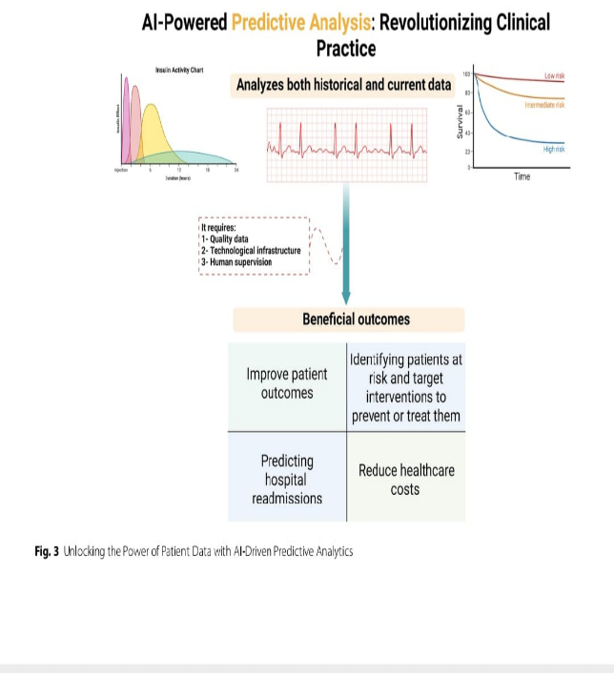
III. CONCLUSION
AI is progressively being used to healthcare, as it became more prevalent in modern days and everyday life. AI has the potential to help healthcare providers in a variety of ways, including patient treatment and administrative tasks. The majority of AI and healthcare innovations are useful in healthcare industry, but the strategies they assist can be different. In some case it claimed that AI can perform well than humans in case of diagnosing sickness. Continuous research continues to add additional capabilities to the technology, resulting in larger advancements in coming years. AI and ML have a lot to contribute in the critical healthcare sector which is undergoing further digital transformations at the moment, and have the possibility to substantially improve quality of life for patients.
REFERENCES
Artificial intelligence in healthcare-by Mahmood Alkhatieb, Abeer A. Subke

Use of AI in dermatology – National Institutes of Health ncbi.nim.nih.gov

Artificial intelligence for skin cancer by Brunna C. R.S. Furriel, Bruno D. Oliveira, Renata Proa, Joselia Q. Paiva https//: www.frontiersin.org

Applications of AI in health care-A review Mohammed Yousef Shaheen
https://www.researchgate.net

AI and data driven Medicine- Forbes.com by Jennifer Kite-Powell senior contributor
https//: www.forbes.com

AI in cardiology: author- Panos Constantinides, David A Fitzmaurice
https://www.researchgate.net

AI in cardiology: author-Loucia Karatzia, Nay Aung, Dunja Aksentijevic

AI in cardiology: by Abid Haleem, Mohd Javaid, Ravi Pratap Singh, Rajiv Suman https://www.researchgate.net

AI -potential benefits and challenges in coronary artery disease by Gemina Doolub

Revolutionizing healthcare: the role of artificial intelligence in clinical practice: by SA Alowais BMC Medical Education. bmcmededuc.biomedcentral.com

